# Hand-out



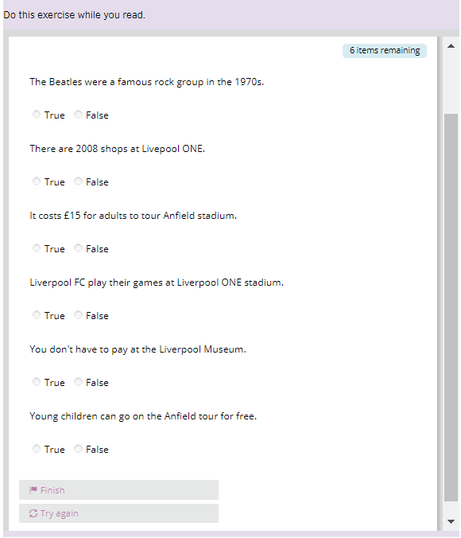

<https://learnenglishteens.britishcouncil.org/skills/reading/elementary-a2-reading/my-city>